**x

**Summer 2022 Edition (June-August)**

Welcome to our newsletter. The aim of the of our newsletter is to keep the community up to date with current guidance and health related events our community can become involved in. If there is a particular topic area or information you would like to see in our next newsletter, please pass this onto one of our PPG members or feel free to join our next PPG meeting. Your opinions are important to us.

**Edzell Health Centre Newsletter**

Unfortunately, **Peter Smart** will be stepping down as chair of the PPG due to health reasons. We would like to take this time to thank him for his valued contribution and hard work.

**Patient Participation Group (PPG)**

**If you answered yes, come join our PPG.**

The PPG is a group of active patient volunteers who work with practice staff to voice concerns and provide a patient perspective on the services provided. **Meetings are quarterly, held at the practice. Ask at reception for details of the next meeting**

Want to make a difference?

Interested in health awareness?

Would you like your voice heard?

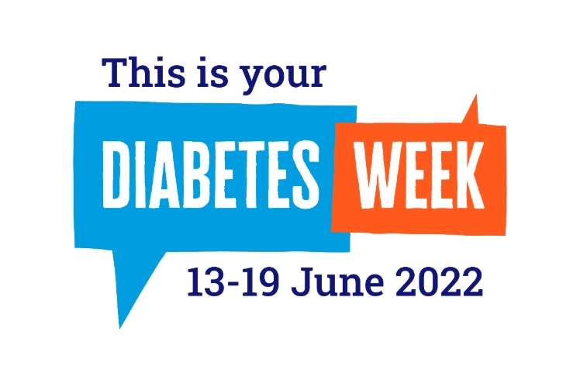

What is Diabetes?

Diabetes is a lifelong condition that causes a person’s blood sugar levels to become high. There are two main types:

**Type One Diabetes**= Where the body’s immune system attacks & destroys the cells that produce insulin.

**Type Two Diabetes**= Where the body does not produce enough insulin, or the body’s cells do not react to insulin.

Symptoms of Diabetes

* Excessive thirst
* Frequent urination, particularly at night
* Feeling very tired
* Recurrent episodes of thrush
* Slow healing wounds & cuts
* Blurred vision
* Weight loss

Living with Diabetes

**1)Eat Healthy**-Reduce salt, regular meals, balanced diet

**2)Keep Active**- Regular exercise e.g., walking, swimming.

**3)Regular check-ups**- Blood pressure, Feet, Eyes, Teeth

**4)Reduce risk**- Stop smoking, take medication as prescribed, attend annual reviews at your GP.





It has been a trying time for the care industry given the challenges faced by the COVID-19 pandemic. The Glad to care campaign aims to increase morale and show appreciation for carers, for their resilience, hard work and extraordinary contributions which is often lacking in public recognition.

Those who work in the care sector often work long hours, often with inadequate breaks. Staff shortages have also added to the daily challenges staff face within this sector, particularly as a result of the impact of COVID-19. Let’s take the time to thank those who care for our loved ones and recognise their hard work and contribution.

**#Gladtocare**

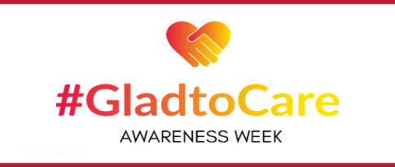

**Awareness Week 20th-24th June**



jcx

**Online Prescription Service**

Patients can now request to sign up to use our **online services** by providing reception staff with an up-to-date email address. Once registered, you will be able to **request your prescriptions remotely**.

**Examples of the benefits of signing up include:**

* **Ability to request prescriptions in your own time.**
* **User friendly system.**
* **Reduces paper waste.**
* **Improves patient satisfaction by reducing dispensing waiting times.**
* **No need to visit your GP**

Since our last newsletter we have seen an increase in the number of patients registering for our online service.

Thank you.

**To register please contact the practice reception, who will be happy to provide help and guidance about registering.**

**Pharmacy First Scotland**

* NHS Pharmacy First allows community pharmacy teams to offer advice, treatment or referrals to other healthcare teams where required.
* They can help individuals with conditions such as sore throats, earache, cold sores & common conditions such as urinary tract infections (UTI).
* Without the need to wait to see their GP or attend their local accident & emergency department for non-urgent treatment.

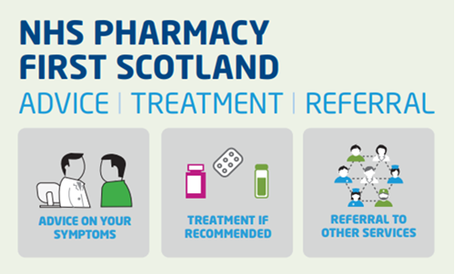

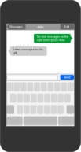

**Practice Updates**

**Public holiday closure**

Monday 25th July 2022

**New members of staff**

We welcome new members to our team: Jane Lyall our new Health care assistant, working Mondays and Wednesdays.

**Appointments**

* All new appointments will be telephone calls initially
* The receptionist will ask for brief details of your call, this enables them to direct you to the most appropriate service.
* Once reviewed by the doctor you may be asked to attend a face-to-face appointment if required.
* Our phone lines may be busier than usual, so we urge the public to remain patient and remember that your call is important to us. We will get to you as soon as we can.
* **If you feel your reason for calling is an emergency and cannot wait, please hang up and call 999.**

**Edzell Health Centre** High Street**,** Edzell, DD9 7TA **Phone**: 01356 648 209 **Email**: [edzellhealthcentre.tayside@nhs.scot](mailto:edzellhealthcentre.tayside@nhs.scot)

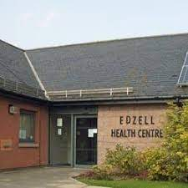

**Reducing our Carbon Footprint**

We aim to ensure we are doing our best to reduce our carbon footprint.

Working together with staff & patients we feel as a team, we can make an impact through small lifestyle changes. Examples include recycling, reducing waste via utilisation of online services, switching off unused appliances & active travel.



**TEXT Messages**

Text messages are being used increasingly, due to the convenience for both our patients and the practice. Texts allow patients to engage with the required actions at a time best suitable to them. We understand text messages may raise concerns over scams so please find our guidance below.

* All official NHS messages are sent by the contact ‘NHS-No Reply’
* The first line of the message from us will be ‘EDZELL HEALTH CENTRE’
* Your message may ask for you to phone the practice or click a link – this is normal
* Genuine messages will never ask for bank details or payments

**Pharmacy First Scotland**

* NHS Pharmacy First allows community pharmacy teams to offer advice, treatment or referrals to other healthcare teams where required.
* They can help individuals with conditions such as sore throats, earache, cold sores & common conditions such as urinary tract infections (UTI).
* This helps to ensure people are accessing **the right care in the right place,** without the need to wait to see their GP or attend their local accident & emergency department for non-urgent treatment.

**Pharmacy First Scotland**

* NHS Pharmacy First allows community pharmacy teams to offer advice, treatment or referrals to other healthcare teams where required.
* They can help individuals with conditions such as sore throats, earache, cold sores & common conditions such as urinary tract infections (UTI).
* This helps to ensure people are accessing **the right care in the right place,** without the need to wait to see their GP or attend their local accident & emergency department for non-urgent treatment.